Generational differences in healthcare employee voluntary turnover:
One retention strategy doesn’t fit all
Working paper, Purdue University: Please do not cite without permission.

Benjamin B. Dunford
Krannert School of Management
Purdue University
403 W. State St.
West Lafayette, IN 47907-2056
Email: bdunford@purdue.edu
Phone: (765) 496-7877

Kirthana Sathyamurthy
Mercer Consulting (India) Pvt Ltd
401, Tower C1, The Millenia, Murphy Road
Ulsoor, Bangalore 560 008, India
Email: kirthana.sathyamurthy@mercer.com
Phone: 91 80 4185 7721

Ingo Angermeier
Spartanburg Regional Healthcare System
101 East Wood Street
Spartanburg, SC 29303
Email: iangermeier@srhs.com
Phone: (864) 560-6000

R. Wayne Boss
Leeds School of Business
University of Colorado at Boulder
Campus Box 419
Boulder, CO 80309
Email: wayne.boss@colorado.edu
Phone: (303) 494-1718

Kathy Sinclair
Spartanburg Regional Healthcare System
101 East Wood Street
Spartanburg, SC 29303
Email: ksinclair@srhs.com
Phone: (864) 560-6564

Susan Duggar
Spartanburg Regional Healthcare System
101 East Wood Street
Spartanburg, SC 29303
Email: sduggar@srhs.com
Phone: (864) 560-6288

Randy Nyp
Spartanburg Regional Healthcare System
101 East Wood Street
Spartanburg, SC 29303
Email: rnyp@srhs.com
Phone: (864) 560-6288
Executive Summary
Voluntary employee turnover is a key problem faced by heath care organizations today, leading to the loss of valuable human capital, selection and training costs for replacements, and reductions in healthcare quality. Although considerable research attention has been devoted to understanding the causes of voluntary turnover in the healthcare industry, most existing research has focused on the organizational, managerial and compensation-related causes, revealing little about age and generation related determinants. Yet research demonstrates that employees of different generations have vastly diverse needs, expectations and challenges, which have a bearing on their decisions to leave an organization. Drawing on lifecycle and generational differences literatures, we examined how the reasons for voluntary turnover varied across generations in a large sample of health care employees over an 8-year period. We found that reasons underlying employee decisions to leave the organization differed significantly across generational cohorts. These findings suggest that retention initiatives should accommodate generational differences to reduce the likelihood of losing key talent.
The voluntary turnover of key talent has become a critical problem in the healthcare industry as the population of skilled employees ages and retires (Aiken, Clarke, Sloane, Sochalski & Silber 2002). For example, the average age of the healthcare workforce population has been projected to reach 45.1 years in 2010 (Buerhaus, Staiger, & Auerbach 2000). Approximately half of US healthcare employees are over 40 and will be eligible for retirement over the next 10 years (Cordeniz 2002). Estimates suggest that turnover in the healthcare industry costs $12.3 billion annually, representing more than 5% of the total annual operating budget of healthcare organizations today (Waldman, Kelly, Aurora, & Smith 2004). These factors make a strong business case for understanding turnover determinants. Accordingly, much empirical research has sought to understand the causes of turnover in the healthcare industry, and has identified job stress, work environment, job satisfaction and compensation as key factors (Chiu, Chung, Wu, & Ho 2009; Lum, Kervin, Clark, Reid, & Sirola 1998). These findings suggest that managers can improve retention though job redesign, improving organizational culture, and restructuring compensation and benefits policies.
However, despite considerable illumination, the causes of employee turnover in the healthcare industry are not fully understood. In particular, a growing body of scholars and practitioners have noted the challenges of managing an intergenerational workforce that differs dramatically in work values, life challenges and expectations of their employer Apostolidis (& Polifroni 2006; Hershatter & Epstein 2010; Ng, Schweitzer & Lyons 2010). Hence, one size does not fit all in designing and implementing employee retention strategies, particularly in healthcare where top talent remains in high demand. Unfortunately to date, little empirical research is available to guide healthcare managers in accounting for generational differences in retention initiatives. Thus, the purpose of this study is to advance the turnover literature in the healthcare sector by examining how the reasons underlying voluntary employee turnover differ across generational cohorts. To that end, we empirically examine turnover decisions in a large sample of healthcare employees over an 8 year period.
Generational Cohorts in the Healthcare Workforce
The healthcare workforce today is an ensemble of employees hailing from various generational cohorts defined as a group of people who have a common range of birth years, and have hence experienced similar social, political, cultural climates growing up that shaped their personal values (Sherman 2006). As each cohort demonstrates different behavioral traits and holds different beliefs from one another, what motivates and interests them also varies. Generational cohorts are further defined by common stages in the lifecycle; employees in the same cohort tend to face similar challenges, and have similar resources as they progress through life (Duchsher & Cowin 2004). We begin by briefly reviewing the common values and life cycle issues confronting three key generational cohorts, Baby Boomers, Generation Xers, and Millennials.
Baby Boomers
Baby Boomers were born between the years 1947-1964 (Cordeniz 2002). Often described as the “individualistic” generation, the Baby Boomers grew up in a fast-growing and rapidly changing economy of the post-World War II period (Zemke, Raines, & Filipczak 2000). As children they constituted 40% of the entire population, resulting in constant competition at schools due to overcrowding, making them highly ambitious, independent and competitive (Hays 1999). Political developments such as the Watergate scandal incited them to not respect authority but to challenge it (Wiley 2000). Baby Boomers known as the driven and dedicated generation who equates work with self-worth (Cordeniz 2002), value helping, and seek to benefit society (Twenge Campbell, Hoffman & Lance 2010). Many employees from this generation occupy leadership positions in health care organizations (Buerhaus et al. 2000).
Today, Baby Boomers are between 47-64 years old and are approaching eligibility for retirement. At this stage of their lifecycle, Baby Boomers often have grown children and may have lesser time commitments towards their children than they did earlier in life (US Census Board Release 2009). They face increasing health problems that affect their ability to meet the physical demands of healthcare work (Santos, Carroll, Cox, Teasley, Simon, Bainbridge, Cunningham & Ott 2003).
Generation X
Generation X employees (or GenXers) were born between 1965 and 1977 (Cordeniz 2002). Unlike the Baby Boomer generation that enjoyed lot of attention as children, many GenXers were brought up in single-parent households or in families where both parents worked, resulting in lesser face-time with their parents (Wiley 2000). Consequently, work-life balance is believed to be a top priority for GenXers (Cordeniz 2002). GenXers began their careers in an economic era of massive corporate layoffs and downsizing (Cordeniz 2002), which is believed to have influenced how they view the employment relationship. Indeed, researchers argue that GenXers view the employment relationship as temporary (Weston 2006). Accordingly, this generation is known for job mobility and maintaining marketability through training (Walker, Martin, White, Norwood, & Haynie 2006).
Today, GenXers are anywhere between 33 to 45 years of age, and commonly have school-age children and aging parents to care for. According to the US Census (2005) 56% of GenXers are married. Of these couples, 80% have children and both parents work full-time. Consequently, GenXers seek balance between family and work life (Apostolidis et al. 2006).
Millennials
Millennials (or Generation Yers), were born between 1978 and 1989 and were raised by parents who could afford them attention and structured upbringing (Cordeniz 2002). Raised in times when violence and terrorism dominated the news, they looked to their family for a sense of security. They grew up to appreciate the value of proper schooling, structured coaching and mentoring (Sherman 2006). Due to their exposure to structured schooling and extra-curricular programs, they are serious about academics have clear career goals and interests (Walker et al. 2006). The American Association of Colleges of Nursing (2005) notes that this generation has shown a keen interest in healthcare careers.
Today, Millennials, who fall in the age range 21 to 32 years, are entering the workforce and establishing a career. They are typically single and do not yet have a family to support, which affords them greater freedom to move geographically (Weston 2006). Millennials form the fastest growing segment of today’s workforce (Walker et al. 2006).
In summary, employees in each of these generations had very different formative experiences, currently face different life stages, and confronting very different life challenges. Table 1 summarizes these differences. As noted above, these generational and lifecycle differences pose dramatic implications for the design of retention practices and policies in healthcare organizations. To provide managers with evidence based prescriptions on retaining top talent, we examine how five common reasons for voluntary turnover (due to scheduling conflicts, inadequate job challenge, better pay elsewhere, educational advancement and health concerns) differ as a function of generational cohort membership (i.e., Baby Boomer, Generation X, and Millennial).
_____________________
Insert Table 1 about here
_____________________
Schedule Conflicts
Anecdotal evidence suggests that scheduling problems are a common reason for turnover in the healthcare industry (Chandra 2003) because healthcare is an around the clock endeavor. Healthcare organizations often struggle to ensure that each department is adequately staffed, and that employee skills match department needs. Managers often confront employees who express difficulty or unwillingness to work overtime, on weekends, holidays, or on particular shifts. Yet we know of no research has been devoted to how much generations differ in leaving over concerns about scheduling conflicts.
Generation X employees are the most likely cohort to have schedule conflicts because they typically have younger families which make their schedules less flexible (US Census Board Release 2005). Employees with such familial responsibilities are often pressed for time as they balance home and work demands (Higgins, Duxbury, & Lee 1994). Moreover, as a generation that grew up with relatively less parental attention (Wiley 2000), and witnessed major organizational restructuring and layoffs as they entered the workforce (Cordeniz 2002), GenXers learned to view jobs as means to an end and continuously strive for work-life balance. Thus, GenXers are more likely than other cohorts to be unwilling to be flexible in meeting schedule demands. Baby Boomers also have scheduling conflicts, but given that their children are older, we expect them to be less likely to present scheduling conflicts with work. Thus, drawing on lifecycle and generational difference perspectives, we hypothesize that:
Hypothesis 1: Voluntary turnover due to schedule conflicts will vary significantly by generation such that it will be highest for Generation X employees, followed by Baby Boomers, followed by Millennials.
Stimulating Work or Job Challenge
Job challenge is defined as the perceived “opportunity for professionals to make full use of their skills” (Raelin 1986: p. 60). Research shows that when employees feel that their talents are underutilized, they experience low job satisfaction, low engagement and higher intentions to leave the organization (Lambert 2001). This is especially so in the healthcare industry where alternative employment opportunities continue to entice top talent. Perceptions of inadequate job challenge can result from numerous factors including a lack of variety in job tasks, organizational policies restricting employee control or autonomy over work, and a lack of opportunity for skill enhancement or career development.
Typologies of work values (Borg 1990; Elizur 1984) distinguish between those that are intrinsic (intellectual stimulation, making societal contributions and job challenge) and those that are extrinsic in nature (job security, salary, promotions, etc). Research suggests key intergenerational differences on these values. Baby Boomers have been found to place a high degree of importance on personal improvement, impact and workplace creativity, reflecting an intrinsic value set (Jurkiewicz 2000) entering the healthcare profession because they wanted to make a difference in the world (Cordeniz 2002). On the other hand, Millennials tend to value extrinsic work characteristics such as pay and status (Cennamo & Gardner 2008; Twenge et al. 2010). Thus, we reason that due to their characteristic needs for achievement and career fulfillment, Baby Boomers turnover decisions may be especially sensitive to job challenge concerns.
Hypothesis 2: Voluntary turnover due to dissatisfaction with job challenge will vary significantly by generation such that it will be highest for Baby Boomers, followed by Generation X employees, followed by Millennials.
Better Pay
In healthcare, it is increasingly common to see top talent leave organizations for better compensation elsewhere (Gering & Conner 2002; Shader et al. 2001). Decades of research show that pay satisfaction is a consistent predictor of employee retention (Cotton & Tuttle 1986). Given the shortage of qualified personnel in the healthcare industry, competitive pay has become an important component in retention (Cohen 2006; Gering & Conner 2002; Numerof 2001; Schweiters 2010).
According to generational difference models, voluntary turnover for better pay elsewhere is likely to vary significantly across generations. Research shows that GenXers place more importance on ‘Work Environment’ and collectively on ‘Work Life Balance’ factors than they do on pay (Wieck, Dols, & Northam 2009). Given their characteristic need for achievement Baby Boomers are likely to place more of a premium on wage advancement (Cordeniz 2002). However, Baby Boomers’ barriers to mobility (e.g., social ties and health concerns) may temper the likelihood of leaving for better compensation elsewhere. In contrast, Millennials have fewer barriers to mobility (Twenge 2006), value extrinsic rewards, and seek a more materialistic lifestyle (Twenge 2006). Hence we reason that Millennials are most likely to quit for better pay elsewhere.
Hypothesis 3: Voluntary turnover for better compensation elsewhere will vary significantly by generation such that it will be highest for Millennials, followed by Baby Boomers and Generation X employees.
Higher Education
The amount of training required to keep pace with the scientific advances in healthcare delivery today is unprecedented. Educational advancement in vocational, degree, and non degree programs is another key reason why healthcare employees leave organizations (Wieck et al. 2009).
Millennials are often noted to have defined career goals and plans (American Association of Colleges of Nursing 2005) and are in the early stage of their careers characterized by skill and knowledge acquisition. In contrast, family commitments and retirement planning are more likely to dictate the employment decisions of GenXers and Baby Boomers. Therefore, we hypothesize that Millennials are more likely to quit for educational advancement.
Hypothesis 4: Voluntary turnover due to educational advancement will vary significantly by generation such that it will be highest for Millennials, followed by Generation X employees, followed by Baby Boomers.
Health Concerns
Research shows that the Baby Boomers’ per capita healthcare expenditures are more than twice those of younger generations (Collins, Davis, Schoen, Doty & Chris 2006). Moreover, the increasing physical demands of healthcare work may be a growing concern for Baby Boomers who may be unable or less motivated to perform such jobs, particularly if less strenuous job alternatives or better healthcare benefits are available in other organizations. As indicated in a study conducted by the American Nursing Association (2001), 88% of the nurses indicated that health concerns had an impact on their decision of continuing working and the kind of work they chose to do. In contrast, GenXers and Millennials are likely to be more physically capable of handling increased physical job demands stress and have fewer health concerns. Thus, drawing on a lifecycle perspective we reason that:
Hypothesis 5: Voluntary turnover due to health related concerns will vary significantly by generation such that it will be highest for Baby Boomers, followed by Generation X employees, followed by Millennials.
Methodology
To study how reasons for turnover vary across generational cohorts, we analyzed an archival turnover dataset from a large healthcare organization in the Southeastern United States. This organization employs approximately 5,000 employees annually, and consists of 312 departments that provide a variety of healthcare services across two hospitals, a regional physician’s network, and several clinics and outpatient facilities. Positions in this organization include a wide range of office and clerical staff, professional services, technical services, nurses, physicians, managers, and administrators. Over the past eight years this organization maintained a stable relationship with its employees, with no significant changes to its leadership, organizational structure, human resource practices, or culture. Pay and benefits remained stable over this period, which included a merit pay system, an annual profit sharing plan and competitive benefits package that had been in place for several years. None of the employees were unionized, and turnover rates remained stable around the industry average.
This organization provided us with personnel records containing information about when and why turnover events occurred, based on exit interviews conducted by immediate supervisors of employees leaving the organization. Our dataset includes all of the turnover events (n = 2,567) that occurred in the organization between 2001 and 2008. In addition to the dates and reasons for turnover, the records also contained age, position and tenure data. We did not include all reasons for employee turnover in the dataset, instead focusing on those reasons that were most theoretically relevant to generational differences.
To test for generational differences in the cited reasons for turnover we followed Cordeniz (2002) by categorizing employees into 3 cohorts based on age: Baby Boomers (born 1947-1964), GenXers (born 1965-1977), and Millennials (born 1978-1989). We used Pearson’s Chi-Square significance tests to examine our hypotheses because both our turnover reasons data and generation data were categorical (Agresti 1996).
Results
The results of our chi-square analyses revealed several interesting generational cohort differences in the reasons for turnover (see Figures 1-4). In support of Hypothesis 1, we found that GenXers were the most likely cohort to leave voluntarily over schedule conflicts, followed by Millennials and Baby Boomers respectively (χ² = 10.21, p < .01). In Hypothesis 2 we predicted that Baby Boomers would be most likely to leave over job challenge concerns. Although we did find a significant difference in exits due to lack of job challenge across the three generational cohorts (χ² = 8.94, p < .01) the pattern was not as we expected; GenXers were the most likely to leave over lack of job challenge followed by Baby Boomers and Millennials. Contrary to Hypothesis 3, we found no generational differences on turnover to for better pay (χ² = 1.60, p > .05). In partial support of Hypothesis 4, we found that Millennials were statistically equivalent with GenXers on leaving for educational advancement, but significantly different than Baby Boomers (χ² = 20.53, p < .01). Finally, in supporting Hypothesis 5, we found that Boomers were most likely to leave for health reasons, followed by GenXers and Millennials respectively. (χ² = 50.35, p < .01). In summary, we found full support for hypotheses 1 and 5, partial support for hypotheses 2 and 4, and no support for Hypothesis 3.
______________________
Insert Figures 1-4 about here
______________________
Discussion
Our results contribute to the literature on the causes of turnover in the healthcare industry by showing that the reasons for turnover varied significantly across generational cohorts in both expected and unexpected ways. Contrary to our expectations we found that turnover for job challenge and educational advancement was highest for GenXers, and that the generational cohorts did not significantly differ on exits for a better pay in other organizations. The primary implication of our results is that one size does not fit all in terms of retaining employees from different generational cohorts. Indeed, healthcare managers should take an evidence-based approach to accommodating generational and lifecycle differences in the development of talent management policies and practices. More research is needed to fully understand how generational differences impact turnover, yet several interesting patterns emerge from this study.
Baby Boomers appear to be voluntarily leaving in part for health related reasons. This may be due to the increasing physical and psychological demands of work in the healthcare space. It is possible that Baby Boomers may be either unable or unwilling to cope with the increasing demands with work, favoring retirement or positions in other organizations, presumably with more favorable work conditions or better health care benefits. In light of these findings, health care managers might consider ways to help Baby Boomers deal with emerging health issues or potential concerns about job stress, either through job redesign or reassignment. The human capital of Baby Boomers is extremely vital to the effectiveness of organizations in the healthcare industry where there is a shortage of top talent. It is essential to retain the tacit knowledge, experience, mentoring and leadership skills of Baby Boomers. Aside from competitive health care benefits and flexible work schedules, participative management practices and reward systems may be helpful to retain them. Indeed, research shows that healthcare employees are more likely to choose working over an early retirement if they have a say in the decision making process and are recognized for their contributions (Sherman 2006).
On the other hand, our data suggest that GenXers may be prone to leave for scheduling conflicts, inadequate job challenge and educational enhancement reasons. GenXers are likely to have growing families, may have spouses that move to pursue other employment or education, or may move for better jobs or educational opportunities themselves. Thus, organizational policies and procedures that grant employees latitude to take care of non-work issues, such as flexible work schedules, telecommuting, non-traditional work weeks, and job sharing may be effective. Moreover, rewards for skill or competency enhancement, funding or time off for educational pursuits, may also be effective retention practices for GenXers who value education. Finally, career and professional development opportunities such as job enrichment, job rotations, job redesign, cross functional training, and internal labor markets may help to retain GenXers who want to be challenged.
Millennials also demonstrated a tendency to exit for reasons relating to educational advancement, which is consistent with their career development life stage and value of education. Providing Millennials with in-house training, funding and time off for educational advancement will help satisfy their need for skill and knowledge acquisition. Finally, healthcare organizations may simultaneously meet the needs of two generational cohorts by pairing Baby Boomers with Millennials in mentoring programs. Organizations would not only benefit from the dissemination of knowledge by Baby Boomers, but also fulfill the needs and expectations of both cohorts (career development focus for Millennials and work involvement for Baby Boomers) thereby reducing the likelihood of turnover. Figure 5 offers evidence based suggestions for how managers could optimize retention strategies for each generational cohort.
______________________
Insert Figure 5 about here
______________________
Limitations and Future Research
Although our research has a number of strengths, in terms of both contributions to the literature and methodology, it has some limitations. First, our study’s focus on a single organization places constraints on the generalizability of its findings. It is possible that the patterns we observed in the data may be different in other organizations. Future research should examine how generational differences impact turnover in other organizations, industries and cultures.
A second limitation is that we were not able to track where employees went after leaving the organization, i.e., to a rival organization, retirement, or to start a different vocation. In future research it would interesting to examine how generational differences impact not only the likelihood of voluntary exit, but the nature of employees’ job or career changes. This research would extend the practical insights of this study.
Third, we did not collect data on retention practices themselves, and were limited to information obtained in exit interviews explaining why employees were leaving. Thus, we cannot make definitive conclusions about the efficacy of specific retention practices for various cohorts. Future research testing the efficacy of various types of retention strategies across generations would be helpful to that end.
Finally, we did not examine a comprehensive list of reasons for why employees leave organizations, instead focusing on theoretically relevant reasons across generations. Future research should examine turnover for a broader variety of voluntary and involuntary reasons including dissatisfaction with co workers or supervisors and disciplinary action.
Conclusion
Most research conducted on healthcare employee turnover has focused on pay, job satisfaction and culture (Chiu et al. 2009; Lum et al. 1998) revealing little about the impact of generational differences in retention. This research takes a step forward in filling that gap by showing that the reasons for voluntary employee turnover differed significantly for Millennials, GenXers, and Baby Boomers. These results suggest that it’s imperative for healthcare managers to account for generational differences in designing and implementing retention strategies to minimize the loss of talent.

References
Agresti, A. 1996. Introduction to Categorical Data Analysis. New York: John Wiley and Sons.
Aiken, L. H., S. P. Clarke, D. M. Sloane, J. Sochalski, and J. H. Silber. 2002. “Hospital Nurse Staffing and Patient Mortality, Nurse Burnout and Job Dissatisfaction.” Journal of the American Medical Association 288 (16): 1987-1993.
American Association of Colleges of Nursing. December 12, 2005. “AACN: With Enrollments Rising for the 5th Consecutive Year, US Nursing Schools Turn Away More Than 30,000 Qualified Applications in 2005.” The America’s Intelligence Wire, December 12, 2005. http://www.accessmylibrary.com/coms2/summary_0286-12017001_ITM.
American Nurses Association (ANA). 2001. “Nursing World.org Health and Safety Survey.” Online article retrieved June 9, 2010 at https://nursingworld.org/surveys/hssurvey.pdf
Apostolidis, B. M., and E. C. Polifroni. 2006. “Nurse Work Satisfaction and Generational Differences.” Journal of Nursing Administration 36 (11): 506-509.
Borg, I. 1990. “Multiple Facetisations of Work Values.” Applied Psychology: An International Review 39 (4): 401-412.
Buerhaus, P. I., D. O. Staiger, D. I. Auerbach. 2000. “Implications of an Aging Registered Nurse Workforce.” Journal of American Medical Association 283 (22): 2948-2954.
Cennamo, L. & Gardner, D. 2008. “Generational differences in work values, outcomes and person-organization values fit.” Journal of Managerial Psychology, 23: 507-523.
Chandra, A. 2003. “Why Do Nurses Leave and What Can Health Organizations Do To Retain Them?” Hospital Topics, 81: 33–36
Chiu, Y., R. Chung, C. Wu, and C. Ho. 2009. “The Effects of Job Demands, Control, and Social Support on Hospital Clinical Nurses’ Intention to Turnover.” Applied Nursing Research 22 (4): 258-263.
Cohen, J. D. 2006. “The Aging Nursing Workforce: How to Retain Experienced Nurses.” Journal of Healthcare Management 51 (4): 233-245.
Collins, S. R., K. Davis, C. Schoen, M. M. Doty, and J. L. Kriss. 2006. “Health Coverage for Aging Baby Boomers: Findings from the Commonwealth Fund Survey of Older Adults.” Volume 9, The Commonwealth Fund.
Compensation data survey. 2007. “2007 Turnover Rates by Industry.” Online article retrieved May 20, 2010 at http://compforce.typepad.com/compensation_force/2008/02/2007-turnover-r.html.
Cordeniz, J. A. 2002. “Recruitment, Retention and Management of Generation X: A Focus on Nursing Professionals.” Journal of Healthcare Management 47 (4): 237-249.
Cotton, J. L., and J. M. Tuttle. January 1986. “Employee Turnover: A Meta-Analysis and Review with Implications for Research.” The Academy of Management Review 11 (1): 55-70.
Duchsher, J. E. B., and L. Cowin 2004. “Multigenerational Nurses in the Workplace.” Journal of Nursing Administration 34: 493-501.
Elizur, D. 1984. “Facets of Work Values: A Structural Analysis of Work Outcomes.” Journal of Applied Psychology 69 (3): 379-389.
Gering, J., and J. Conner. 2002. “A Strategic Approach to Employee Retention.” Healthcare Financial Management.” November: 40-44.
Hays, S. 1999. “Generation X and The Art of The Reward.” Workforce (November): 44-48.
Hershatter, A., and M. Epstein. 2010. “Millenials and the World of Work: An Organization Management Perspective.” Journal of Business and Psychology 25: 211-223.
Higgins, C., L. Duxbury, and C. Lee. 1994. “Family Relations, Impact of Life-Cycle Stage and Gender on the Ability to Balance Work and Family Responsibilities.” National Council on Family Relations 43 (2): 144-150.
Jurkiewicz, C. L. 2000. “Generation X and the Public Employee.” Public Personnel Management 29 (1): 55-74.
Lambert, E. G., N. L. Hogan, and S. M. Barton. 2001. “The Impact of Job Satisfaction on Turnover Intent: A Test of a Structural Measurement Model Using a National Sample of Workers.” The Social Science Journal 38 (2), 233-250.
Lum, L., Kervin, J., Clark, K., Reid, F., & Sirola, W. 1998. “Explaining nursing turnover intent: job satisfaction pay satisfaction or organizational commitment?” Journal of Organizational Behavior 19: 305-320.
Ng., E. S. W., L. Schweitzer, and S. T. Lyons. 2010. “New Generation, Great Expectations: A Field Study of the Millennial Generation.” Journal of Business and Psychology 25: 281-292.
Numerof, R. E. 2001. “Retaining Employees: Lessons From the Best.” Healthcare Executive 16 (2): 62-64.
Parry, E., & Urwin, P. 2010. “Generational differences in work values: A review of theory and evidence.” International Journal of Management Reviews, Pre-published online, June 2010 as doi: 10.1111/j.1468-2370.2010.00285.x.
Raelin, J. A. 1986. Clash of Cultures: Managers Managing Professionals. Boston: Harvard Business School Press.
Santos, S. R., Carroll, C. A., Cox, K. S., Tasley, S. L., Simon, S. D., Cunningham, M., & Ott, L. 2003. “Baby boomer nurses bearing the burden of care. A four-site study of stress, strain and coping for inpatient registered nurses.” The Journal of Nursing Administration, 33 (4), 243-250.
Schweiters, J. 2010. “Strategies for Dealing with the National Coding Shortage.” Healthcare Financial Management 64 (4): 36-38.
Shader, K., Broome, M. E., Broome, C. D., West, M. E., & Nash, M. N. 2001. “Factors influencing satisfaction and anticipated turnover for nurses in an academic medical center.” Journal of Nursing Administration 31 (4): 210-216.
Shader, K., M. E. Broome, C. D. Broome, M. E. West, and M. N. Nash, 2001. “Factors Anticipating Satisfaction and Anticipated Turnover for Nurses in an Academic Medical Center.” Journal of Nursing Administration 31 (4): 210-216.
Sherman, R. 2006. "Leading a Multigenerational Nursing Workforce: Issues, Challenges and Strategies". The Online Journal of Issues in Nursing, 11 (2), Manuscript 2. Online article retrieved June 10, 2010 at: www.nursingworld.org/MainMenuCategories/ANAMarketplace/ANAPeriodicals/OJIN/TableofContents/Volume112006/No2May06/tpc30_216074.aspx
Twenge, J. M. 2006. Generation Me: Why today’s young Americans are more confident, assertive, entitled—and more miserable than ever before. New York: Free Press.
Twenge, J. M. 2010. Generational differences in work values: Leisure and extrinsic values increasing, social and intrinsic values decreasing. Journal of Management, Pre-published online, March 2010 as doi:10.1177/0149206309352246.
US Census Board Release, Wednesday, February 25, 2009. “As Baby Boomers Age, Fewer Families Have Children Under 18 at Home.” Online article retreived June 9, 2010 at http://www.census.gov/newsroom/releases/archives/families_households/cb09-29.html
Waldman, J. D., Kelly, F., Aurora, S., & Smith, H. L. 2004. “The Shocking Cost of Turnover in Health Care.” Health Care Management Review 29 (1): 2-7.
Walker, J. T., Martin, T., White, J., Norwood, A., & Haynie, L. October 1, 2006. “Generational Age Differences Impact the College Classroom.” Journal of the Mississippi Academy of Sciences 52 (1): 97-106.
Weston, M. May 31, 2006. “Integrating Generational Perspectives in Nursing.” The Online Journal of Issues in Nursing 11(2): Manuscript 1.
Wieck, K. L., J. Dols, and S. Northam. 2009. “What Nurses Want: The Nurse Incentives Project.” Nursing Economics 27 (3): 169-177.
Wiley, D. L. 2000. “Developing Information Leaders: Harnessing the Talents of Generation X.” Ecotent, December 85-87.
Zemke, R., C. Raines, and B. Filipczak. 2000. Generations at Work: Managing the Clash of Veterans, Boomers, Xers, and Nexters in Your Workplace. New York: AMACOM.

Table 1: Characteristics, Job Expectations and Life Priorities of Generations

 | Millennials | GenXers | Baby Boomers
Characteristics | • Expert multi-taskers  • Work well in teams  • Embrace technology | • Self-reliant  • Loyal to self and career not job or organization | • Optimistic  • Strong work ethic  • Attach themselves to work
Life Cycle Stages | • Mostly single  • Fewer family commitments | • Most have wage earning spouse  • Younger children | • Emerging health concerns  • Children grown
Job Expectations | • Advancement  • Technology-rich environment  • Higher pay | • Work-life balance  • Fun on job  • Informality  • Focus on outcome, not processes | • Rewards for good performance  • Societal impact  • Opportunities to help others
Sources: Cordeniz (2002), Walker et al. (2006), Hays (1999), Twenge et al. (2010), Weston (2006), Wiley (2000), Zemke et al. (2000)

Figure 1. Generational differences in schedule concerns as a reason for voluntary turnover

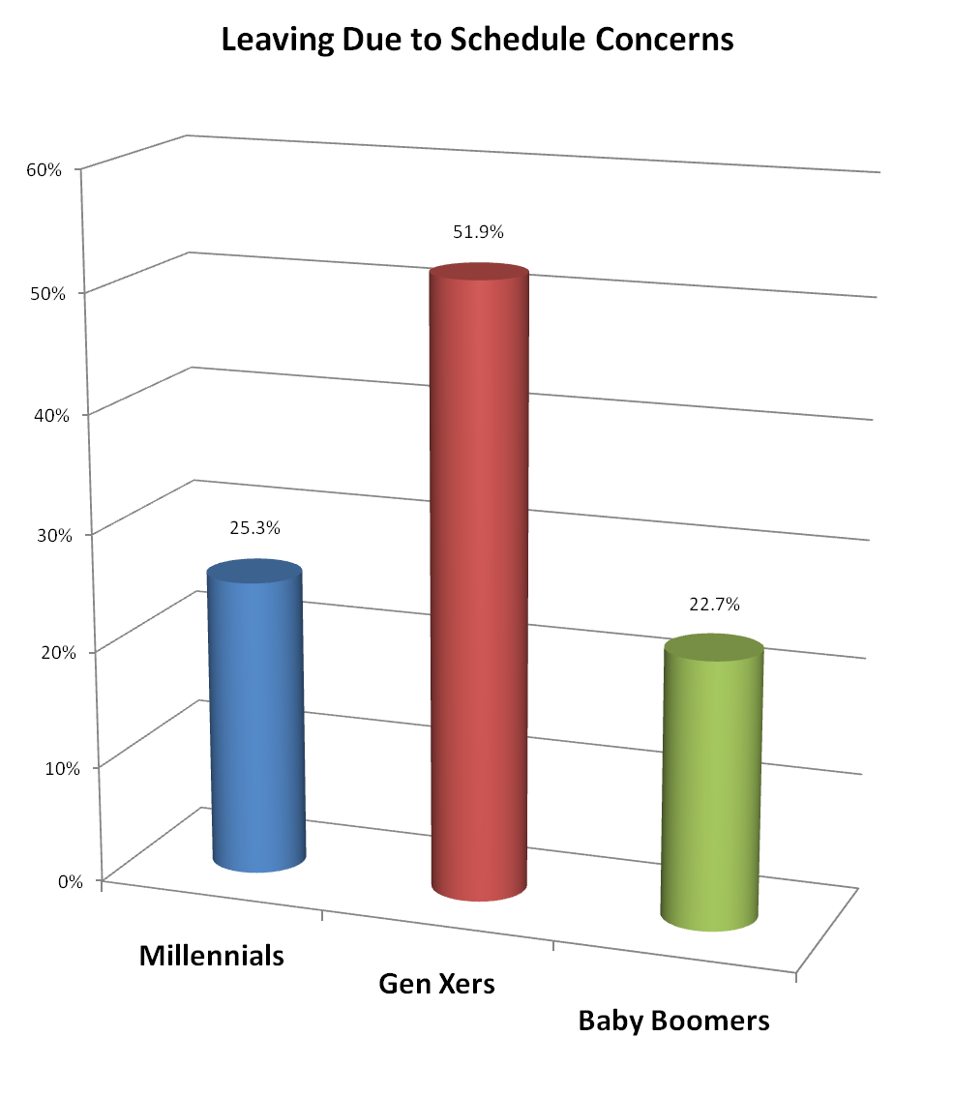

Figure 2: Generational differences in job challenge concerns as a reason for voluntary turnover
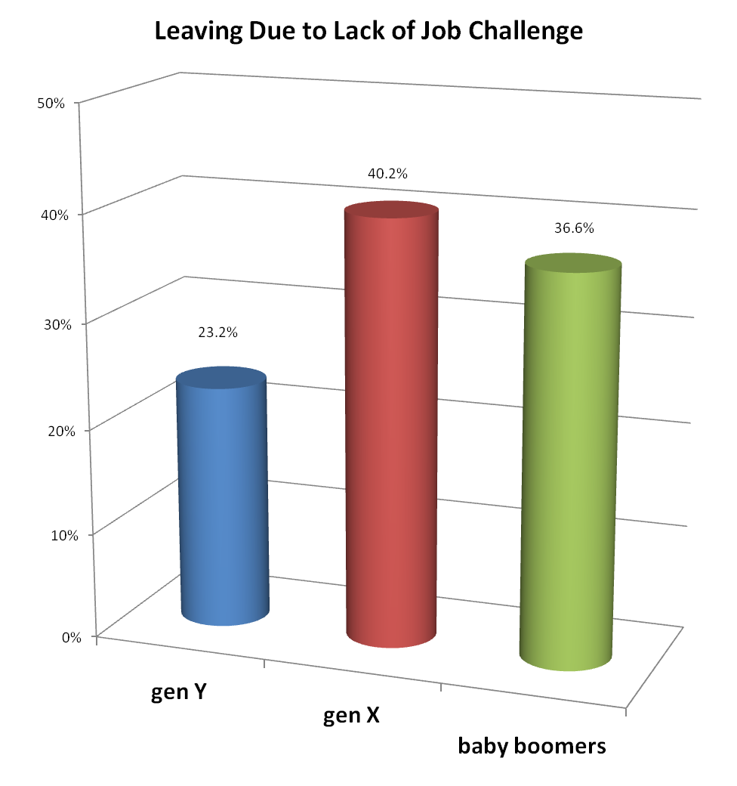
Baby Boomers
Gen Xers
Millennials

Figure 3: Generational differences in educational advancement as a reason for voluntary turnover

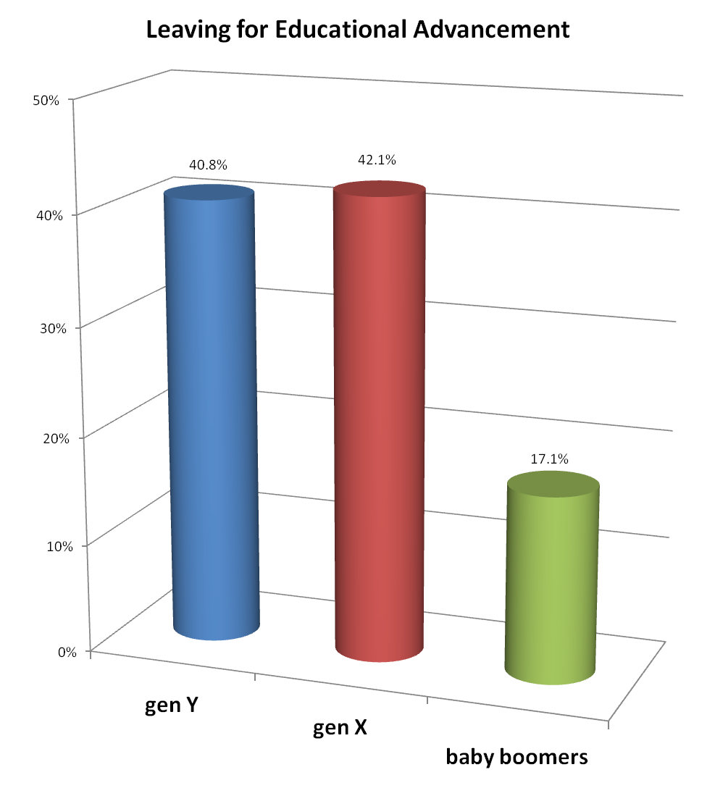
Baby Boomers
Gen Xers
Millennials

Figure 4: Generational differences in health concerns as a reason for voluntary turnover

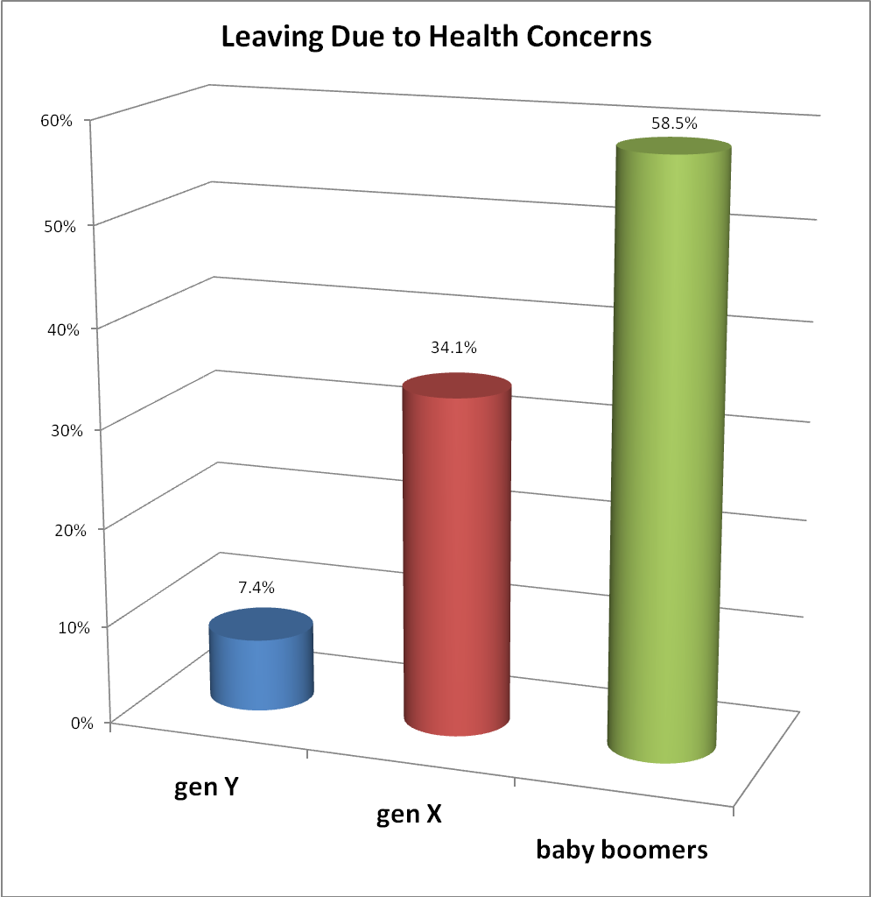
Baby Boomers
Gen Xers
Millennials

Figure 5. Recommended retention strategies for generational cohorts

